**Software Project Management (SE3080)**

**Assessment on Tools**

|  |  |  |  |
| --- | --- | --- | --- |
| **Group Number** | **SPM_19_RSE_WE_15** | | |
| **Name** | | **Registration No** | **Signature** |
| **D.I.K. Rajapakshe** | | **IT16178700** |  |
| **M.P.P. Shamil** | | **IT17018760** |  |
| **P.M.C.P. Paththinisekara** | | **IT17056212** |  |
| **S.K. Liyanage** | | **IT17152938** |  |

**Table of Contents**

Targetprocess 1

SonarQube 6

GitHub 11

Selenium 14

# Targetprocess

# 

1. Backlog

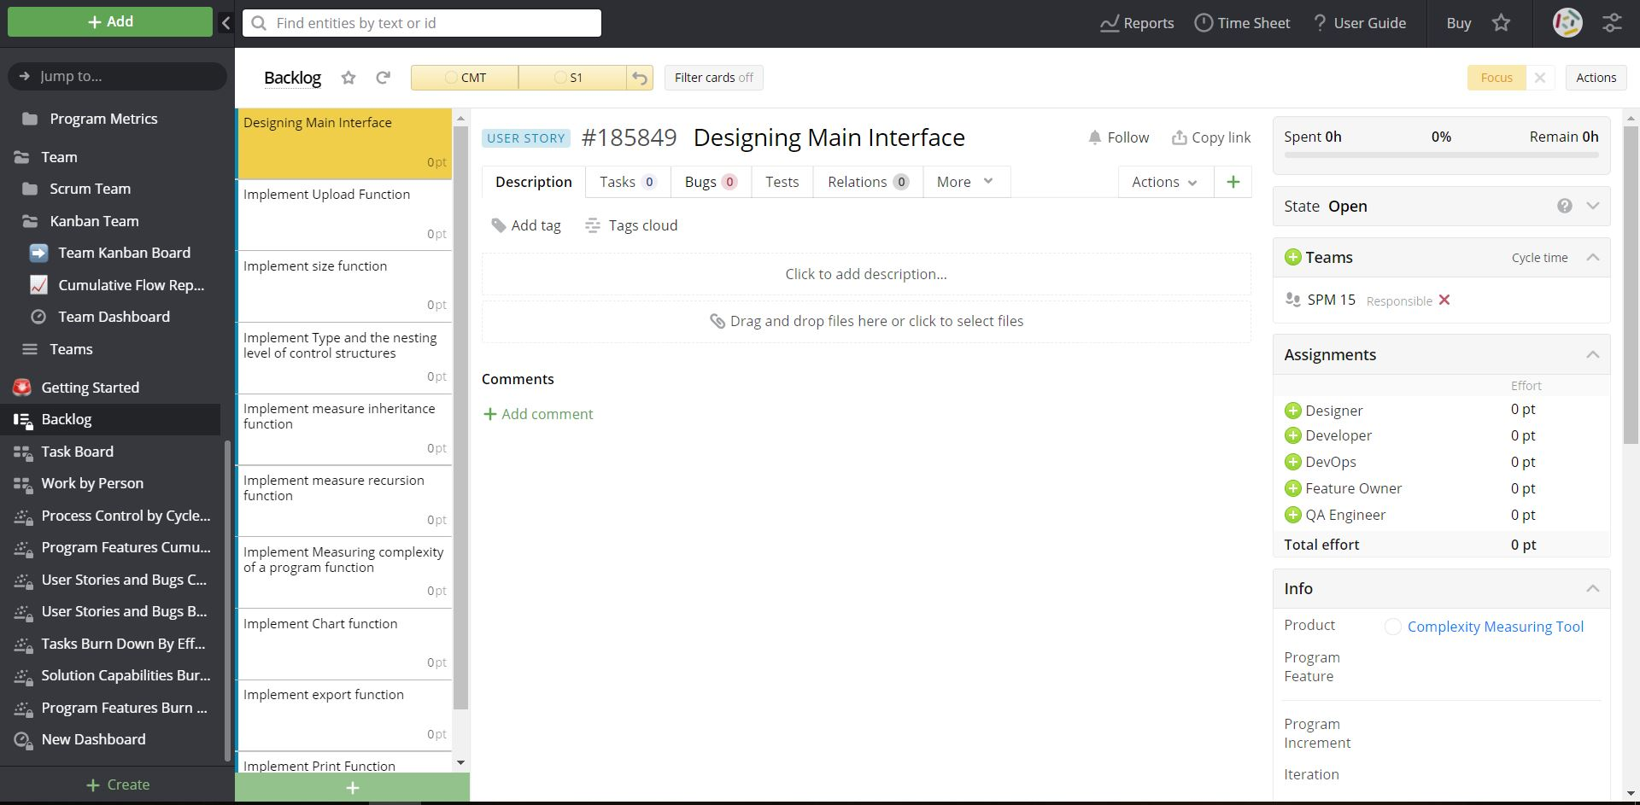

1. Individual task board summary
2. 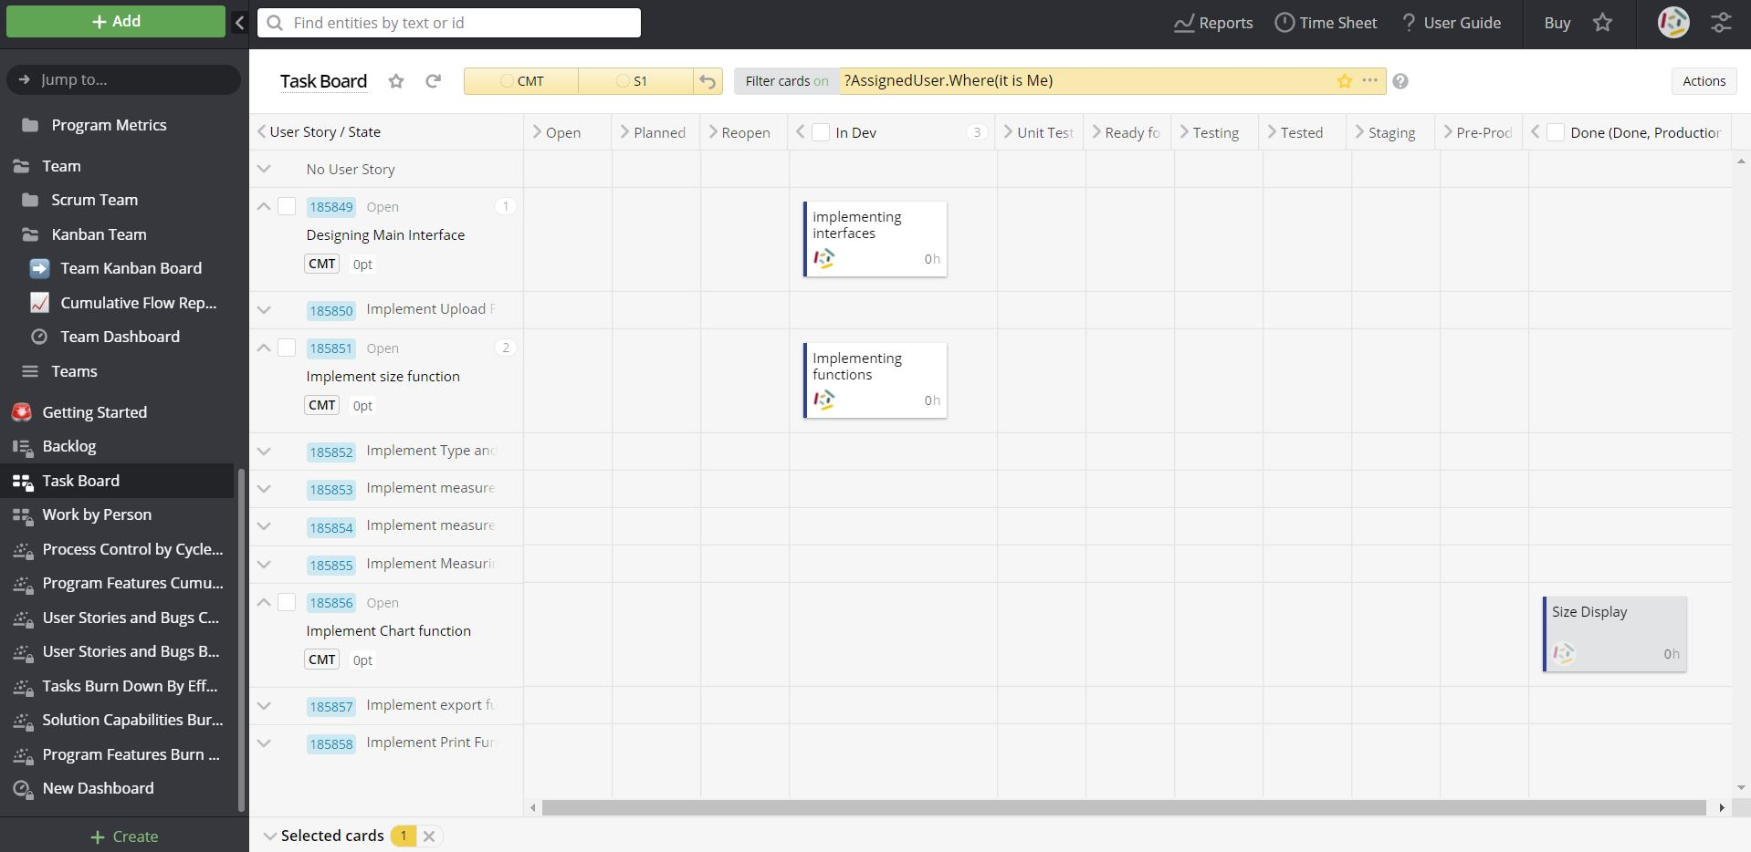IT17056212 - Task board summary
3. IT16178700 - Task board summary

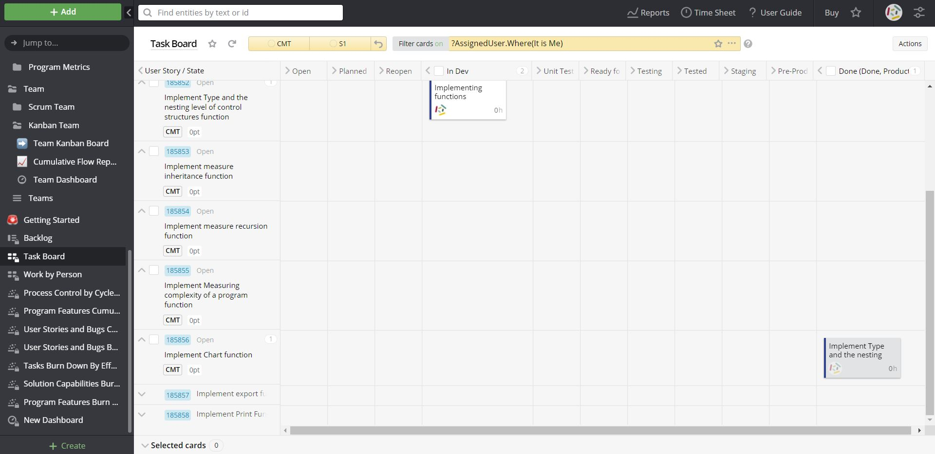

1. IT17018760 - Task board summary

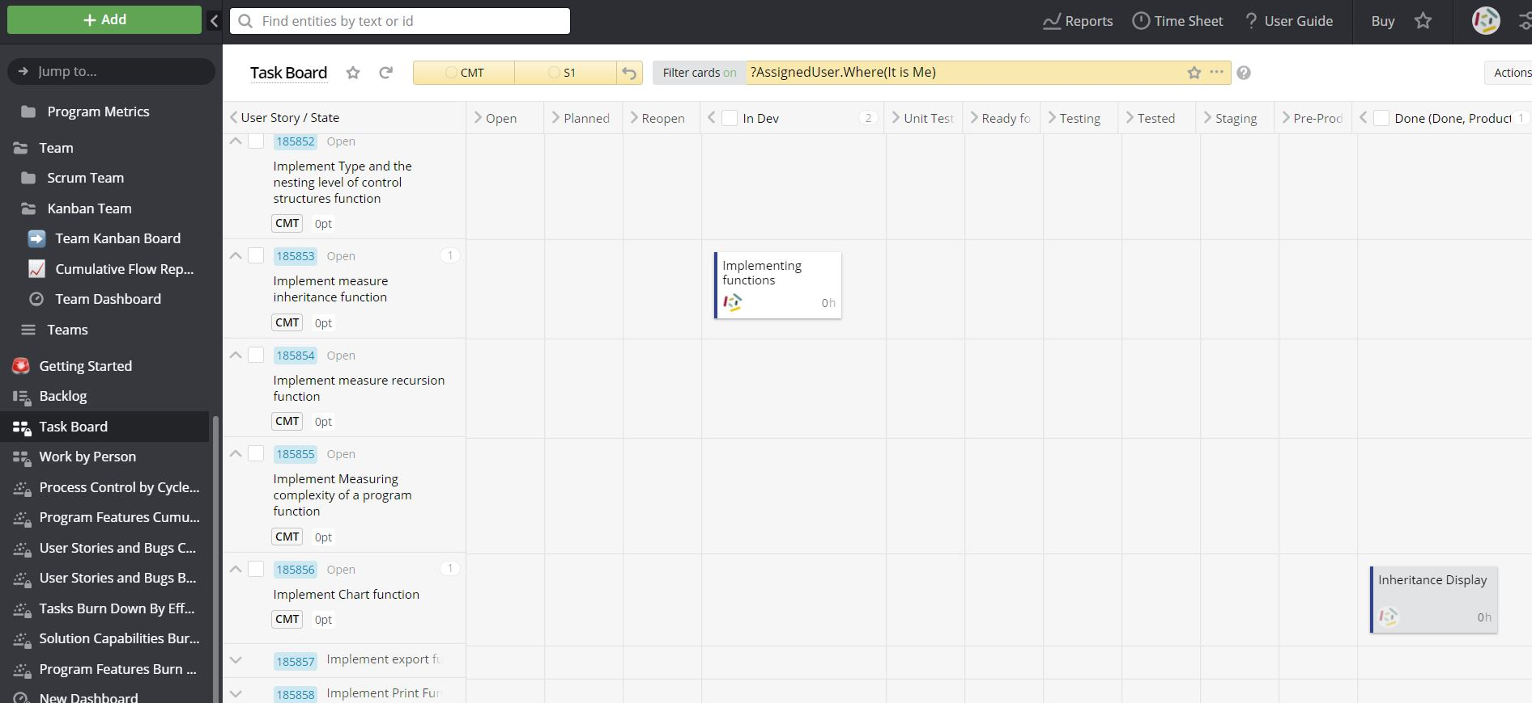

1. IT17152938- Task board summary

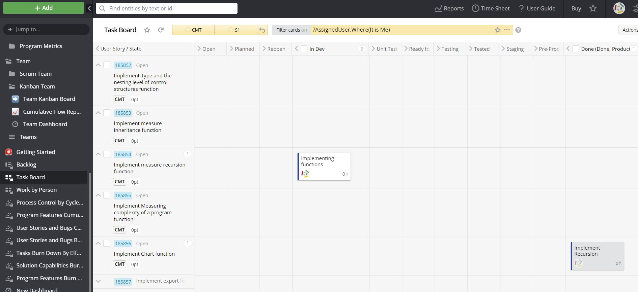

1. Individual task board summary

# 

1. Role by person

# 

1. Process control chart

# 

1. Burn down chart

# 

1. Cumulative flow diagram

# 

# SonarQube

1. Overview status of analyzed projects

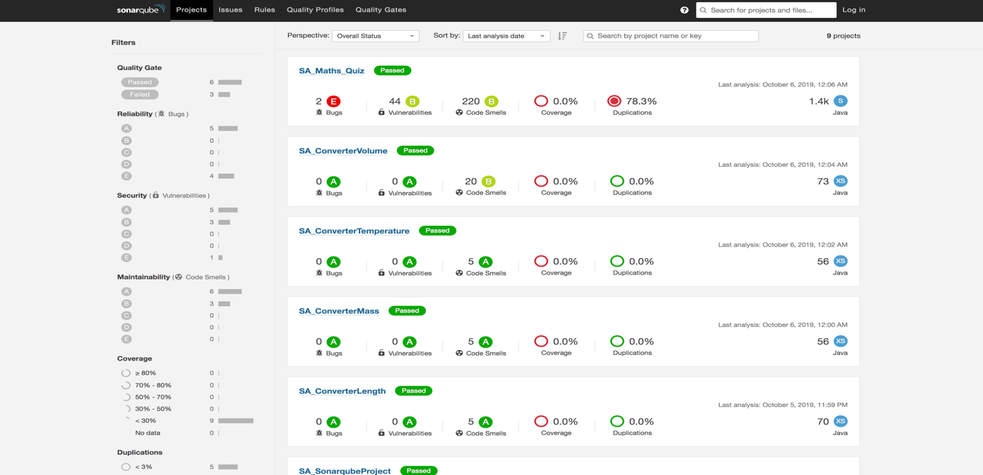

1. Apply filter for projects.

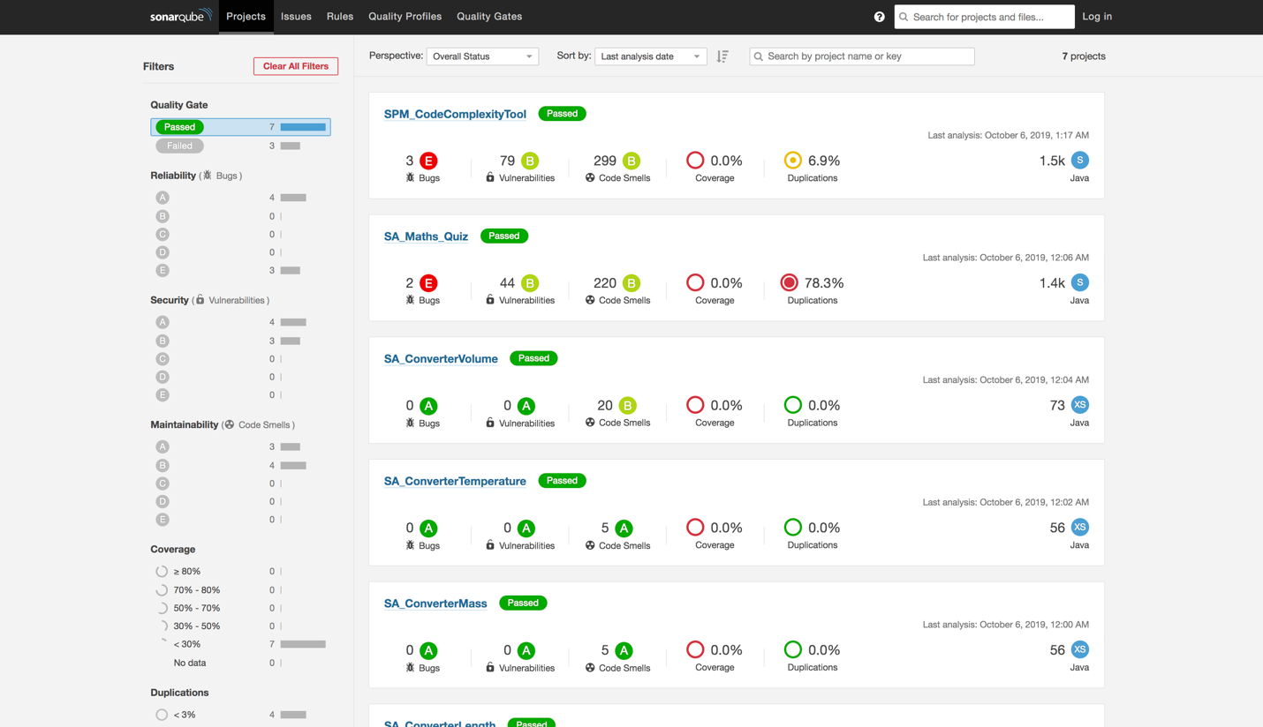

1. Project Overview.

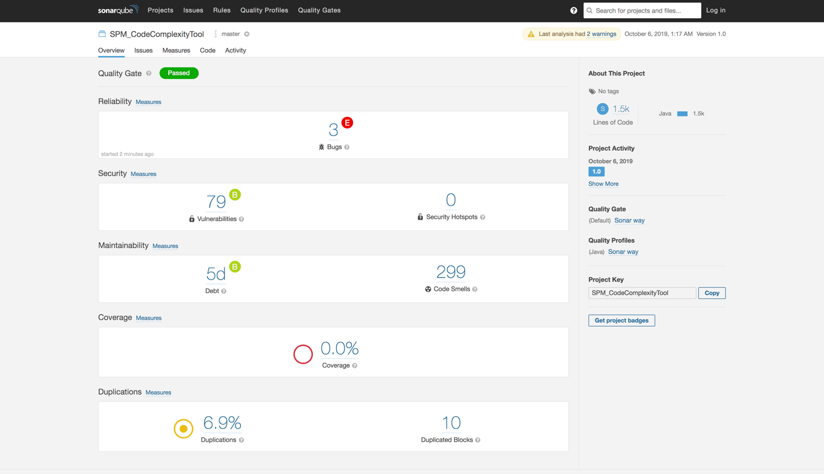

1. Project Issues

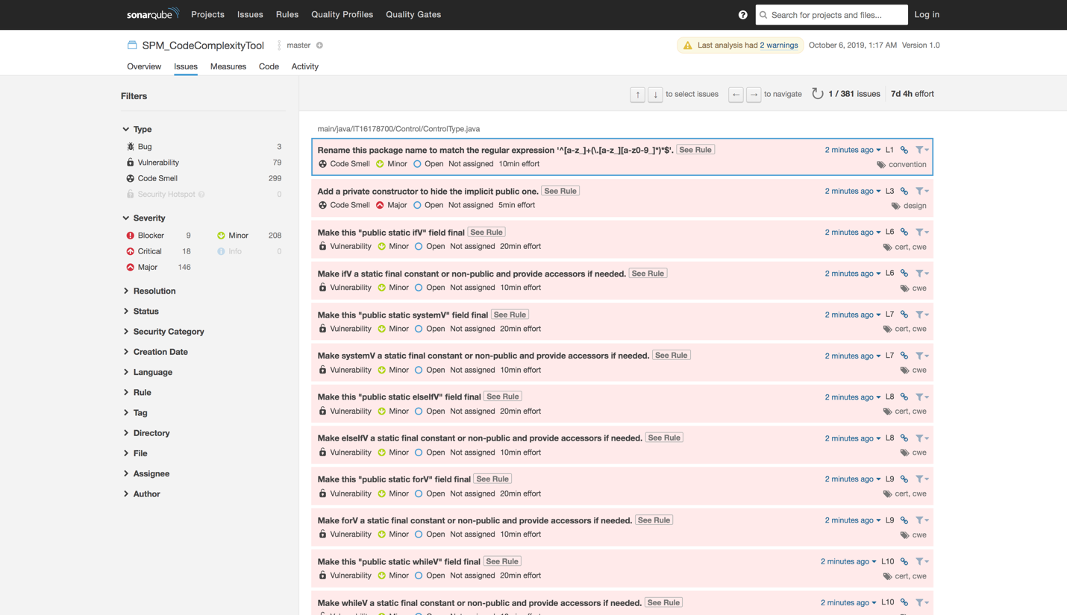

1. OWASP Top 10 Security Report

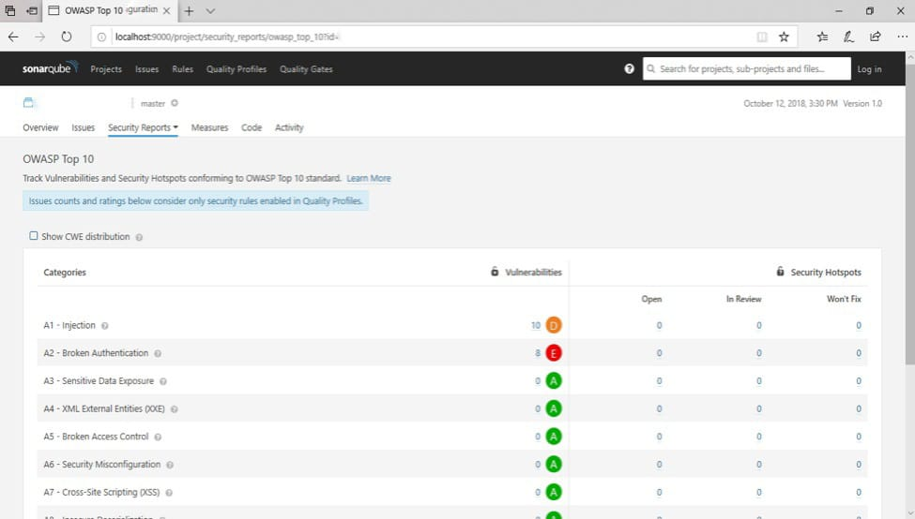

**SPM_CodeComplexity**

1. Project Security

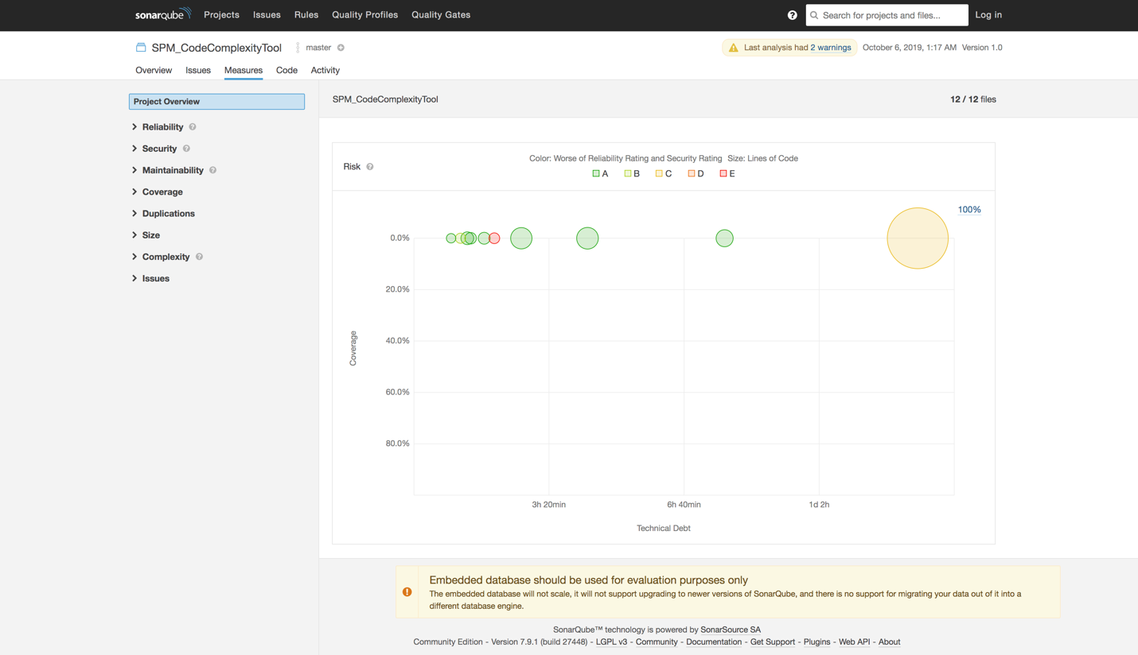

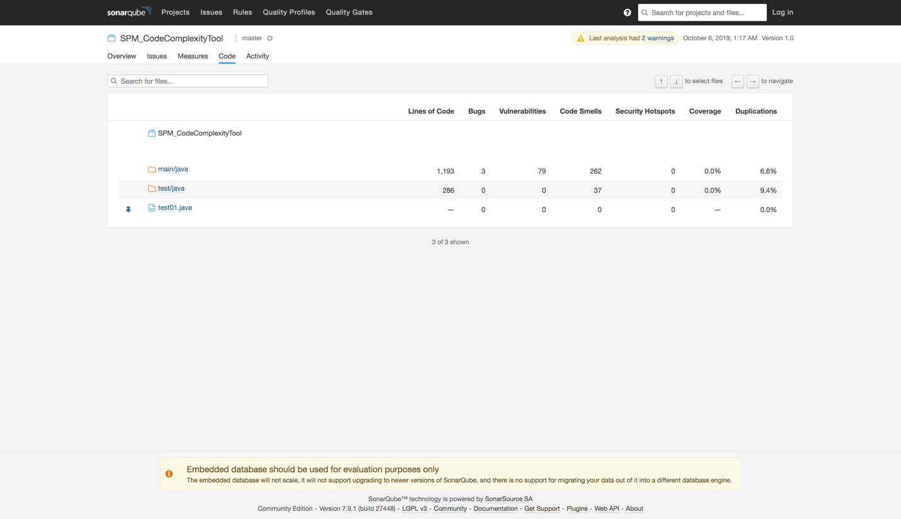

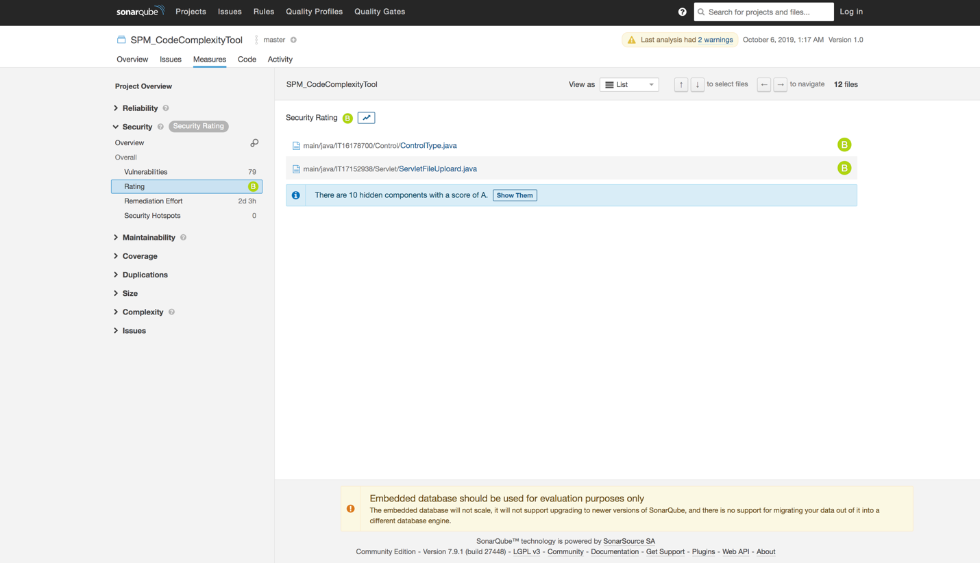

1. Sonar-scanner.properties

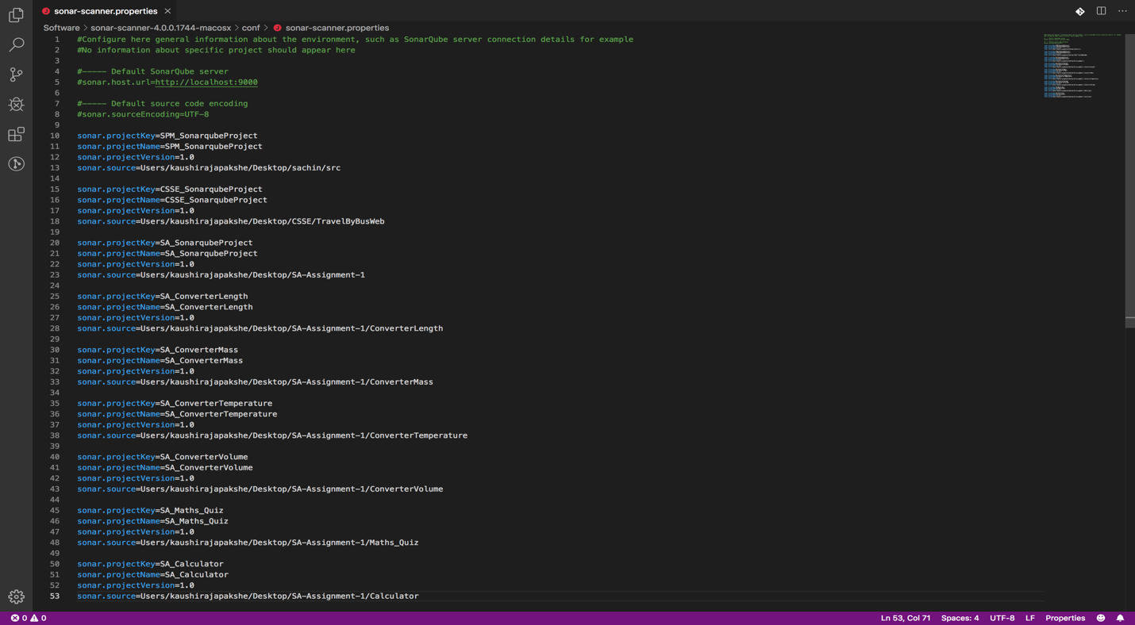

1. Sonar-scanner

Path : - Software/sonar-scanner-4.0.0.1744-macosx/bin

sh sonar-scanner -Dsonar.projecktKey='SPM_CodeComplexityTool -Dsonar.projectBaseDir='/Users/kaushirajapakshe/Desktop/SA-Assignment-1/SPM -Dsonar.sourse=. -Dsonar.java.binaries=.

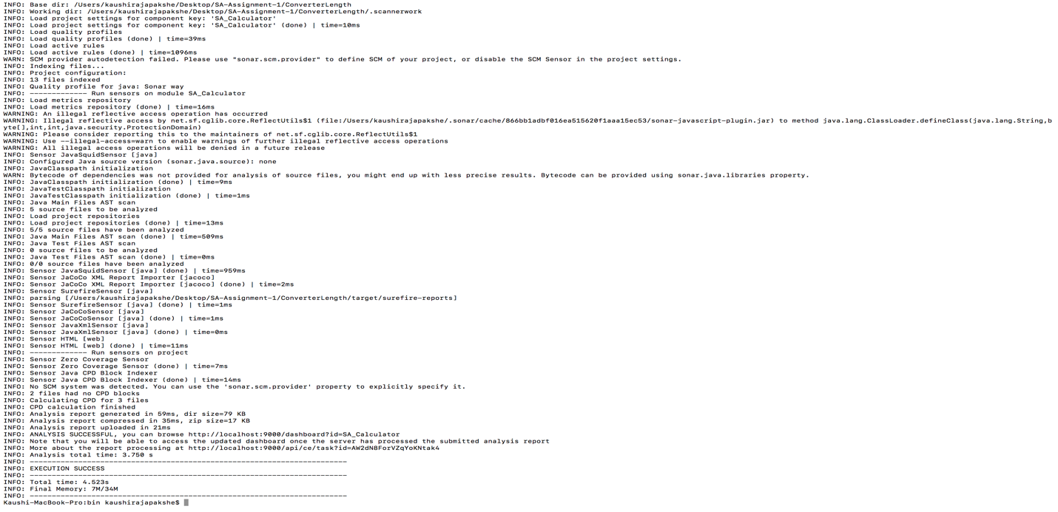

# GitHub

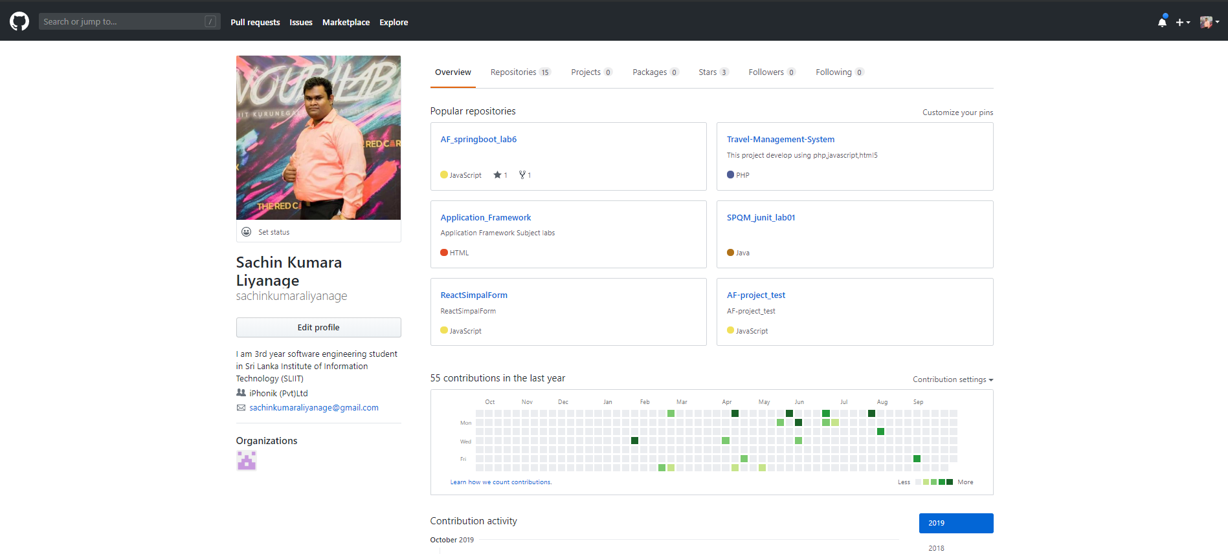1. Repository view

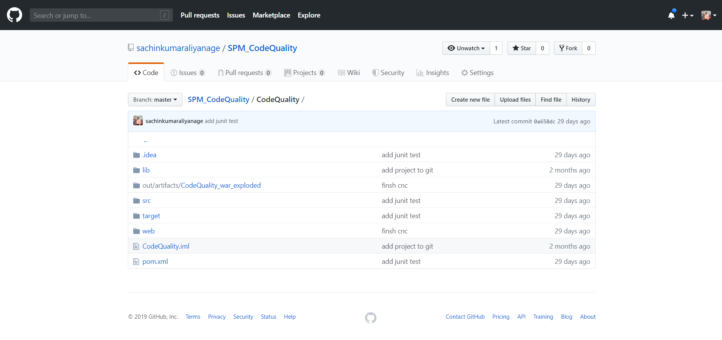2. File setup

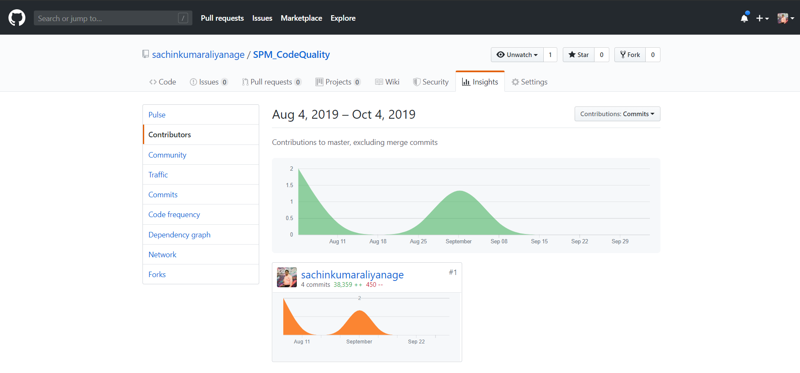3. Contributors

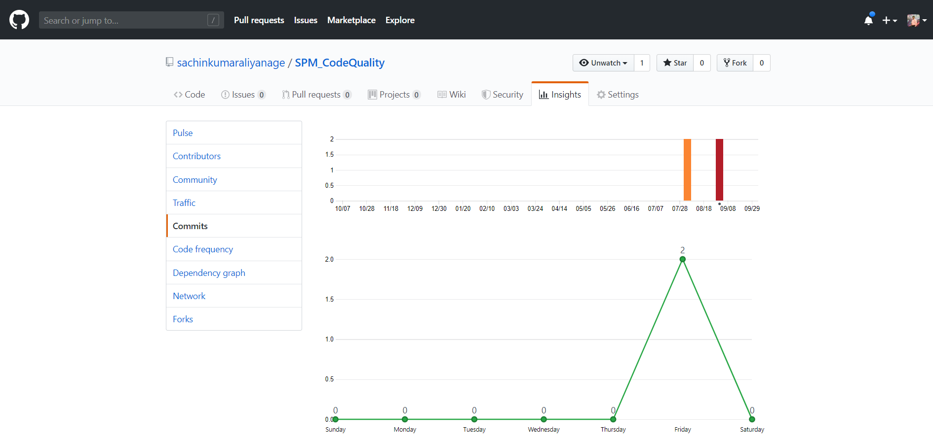4. Commit Activity

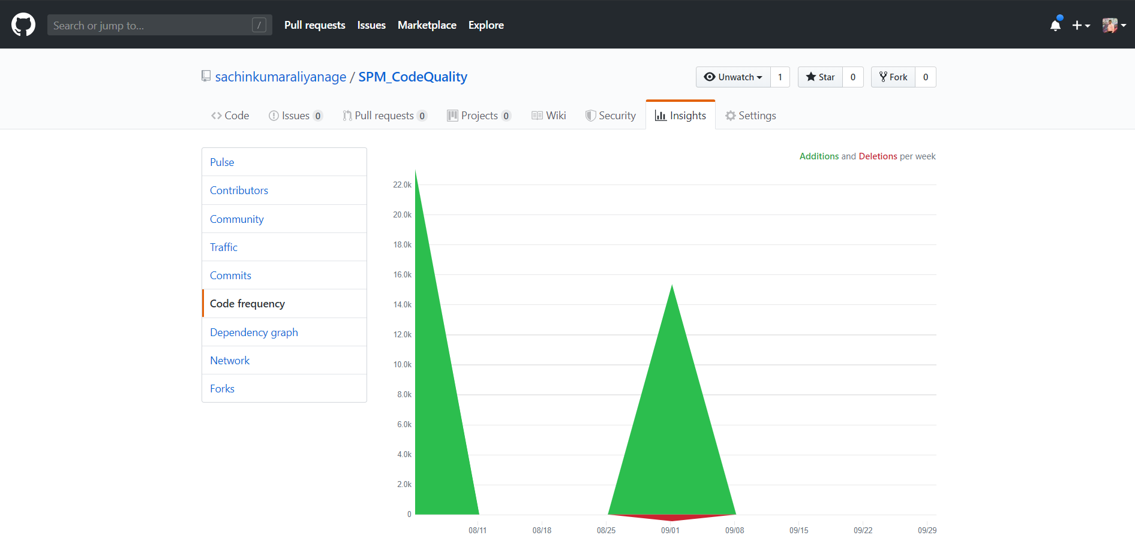5. Code Frequency

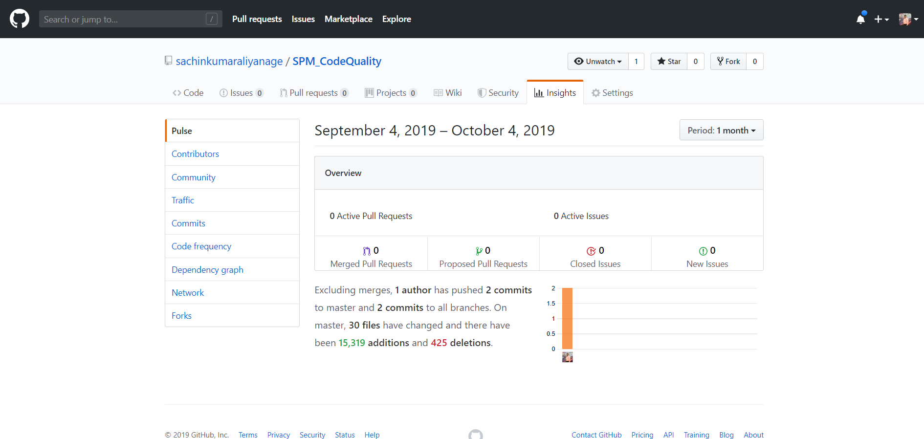6. Pulse

# Selenium

1. **Selenium IDE with the base URL**

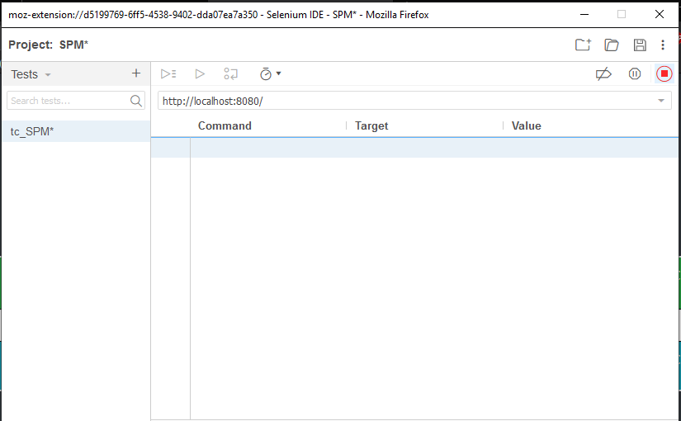

1. **Automation test script**

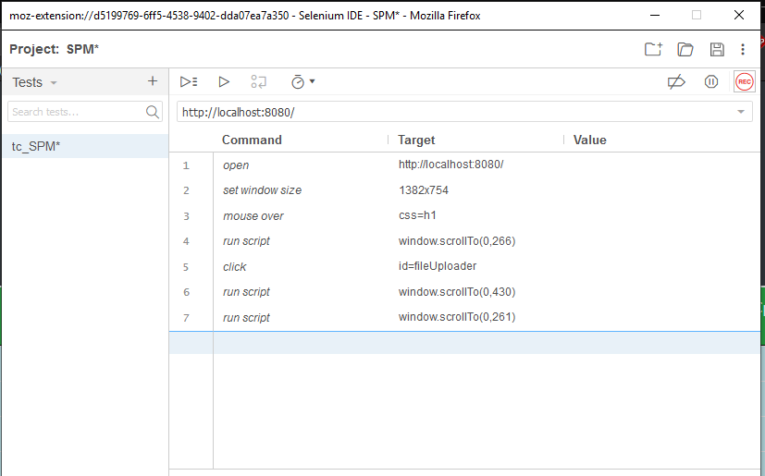

**3.Selenium IDE after running the test case**

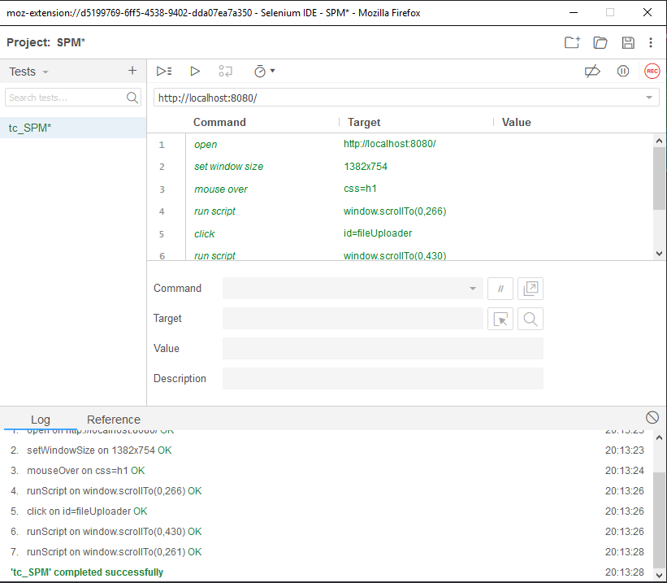

**4.Verify items on the page**

